Weekly Feature Car Questionnaire
What is your name and where are you from?
Does your car have a name?
What is the year, make, model/trim or option level?
What is the motor, transmission and rearend?
What wheels or wheel covers and tires does it have?
What are the exterior and interior colors?
How long have you had it and how did you come about owning it?
Is it all original? If not, what has been modified?
Did you do the modifications yourself or who has helped you?
Why did you pick a MoreDoor?
What is something cool about it or a unique feature of it?
How is it special to you or what significance is it to you?
What are your future plans for it?
How often do you get to drive it or take to shows and/or cruise-ins?
Do you have a favorite place to take it?
Do you have any memories of other MoreDoor Classics?
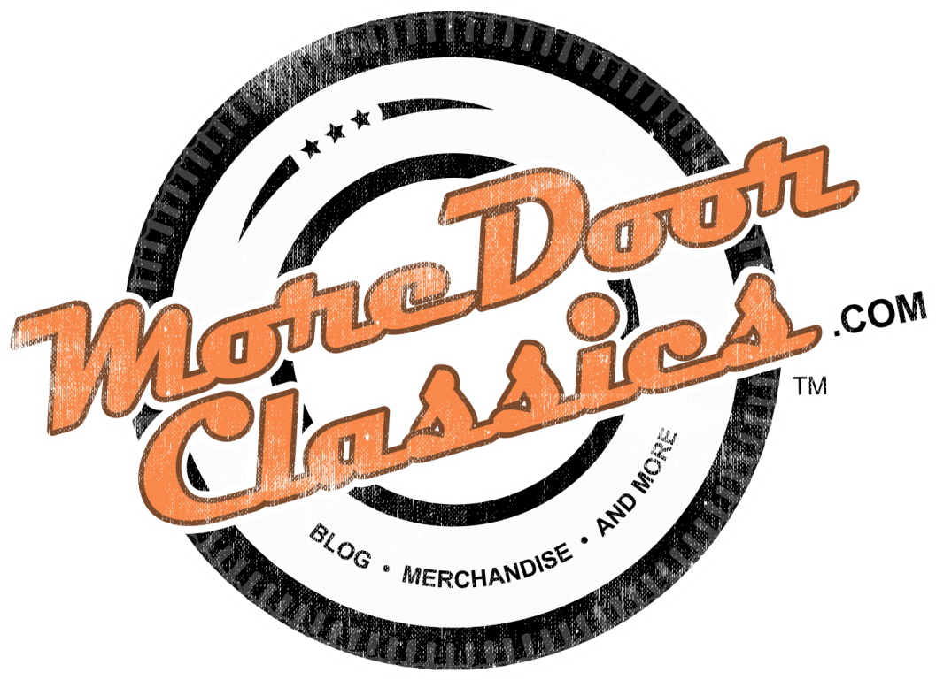
www.moredoorclassics.com
moredoorclassics@gmail.com

